5-6 July 2012
University of Edinburgh
John McIntyre Conference Centre

Language Futures

Languages in Higher Education conference 2012

6th edition

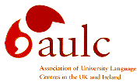
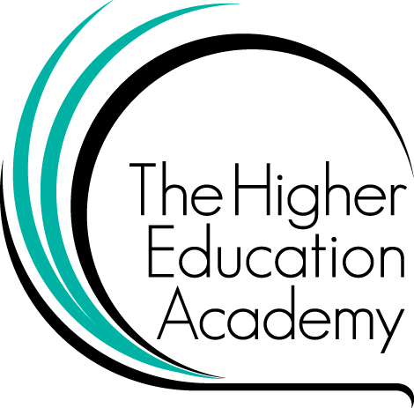

In partnership with

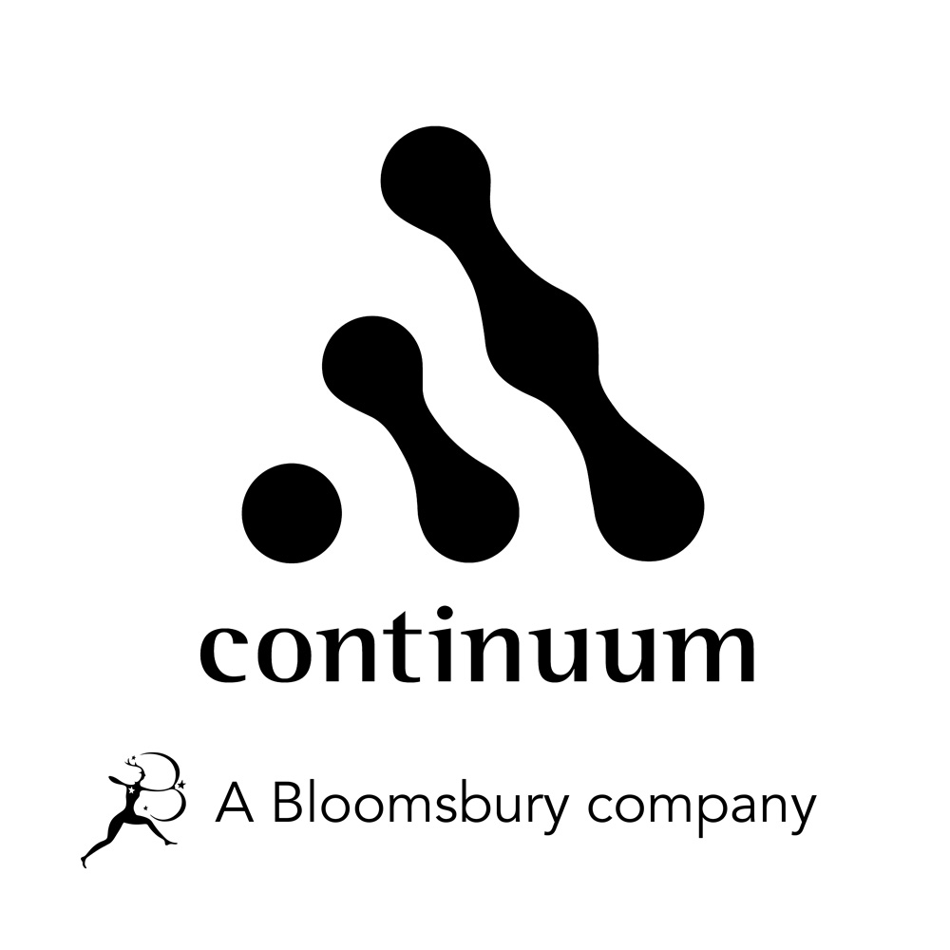
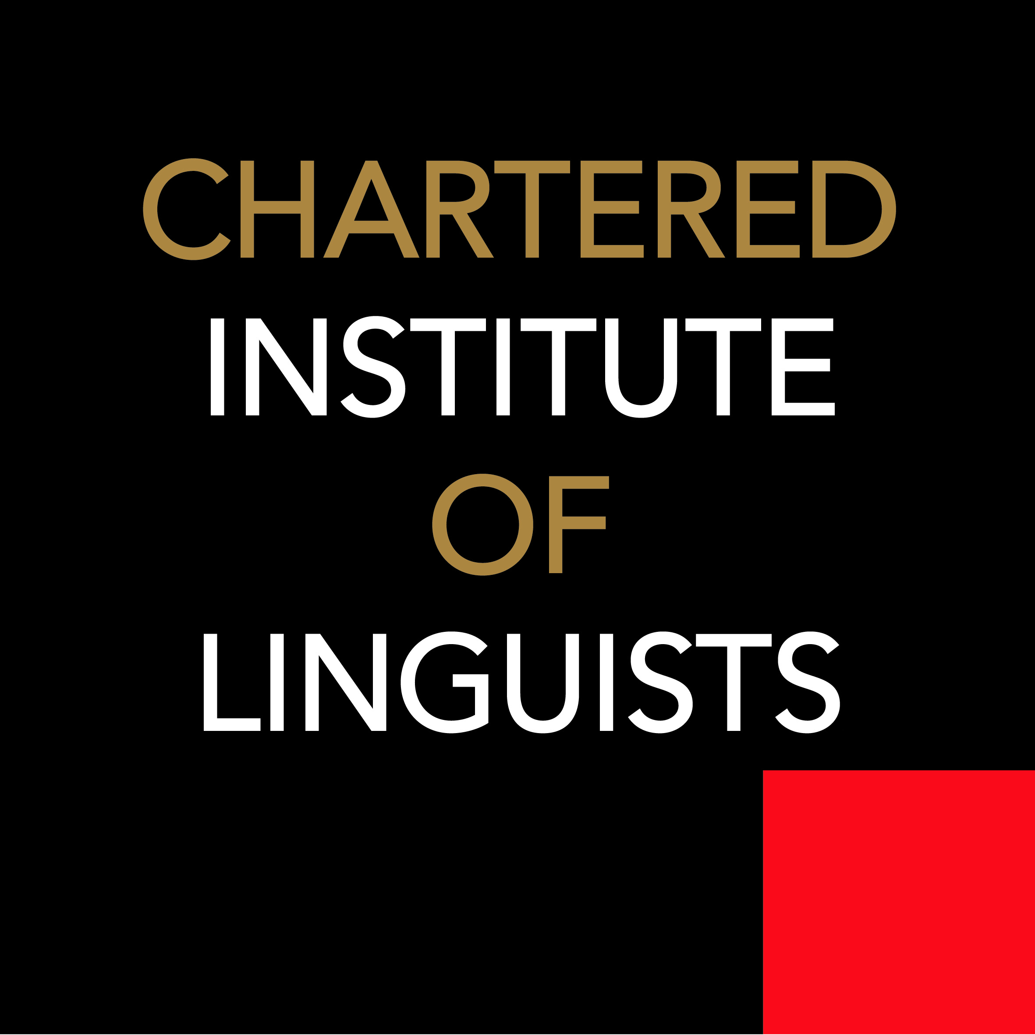
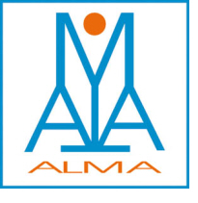
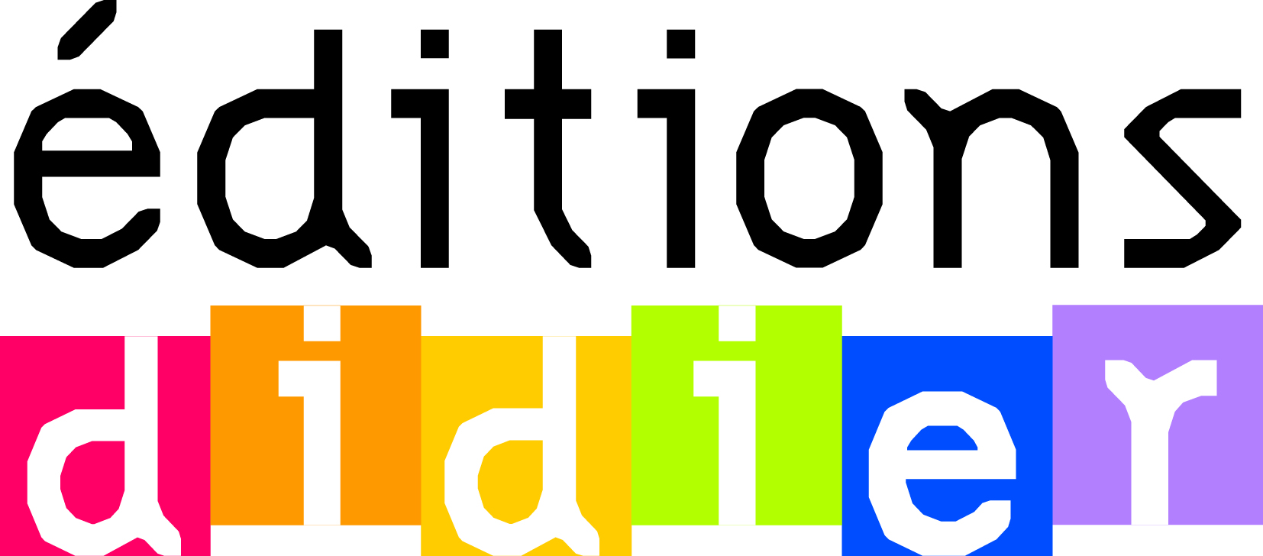
Supported by

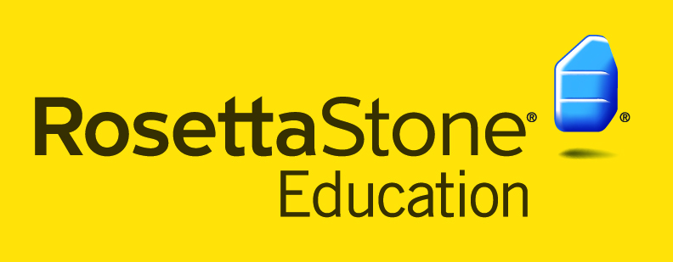
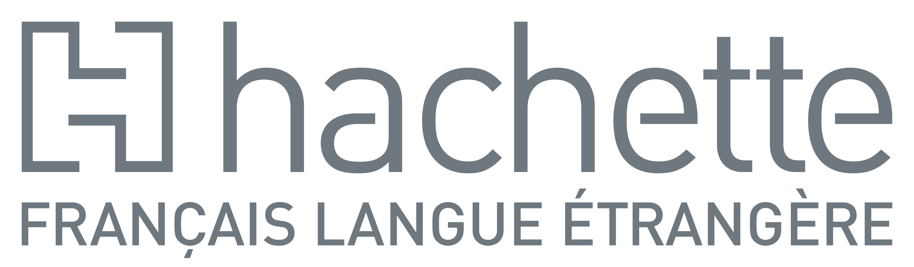
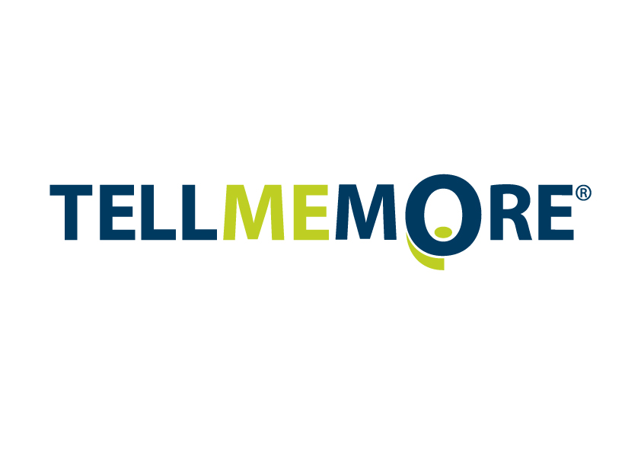
Welcome

Dear colleagues,

The world is a different place from the one we knew in 2002, when the first of these two-yearly conferences was held. In that time, the importance of languages has not ceased to grow. The last twelve years have shaken much of the complacency about our ability to understand what is going on in the wider world. In fits and starts policy makers have begun to wake up and smell the coffee.

The title of the conference, Language Futures, is a reminder that the future is a risky business, full of uncertainties. But it is also an affirmation of our belief that languages are a key resource for the future and offer many opportunities which we need to know about.

The programme provides a rich panorama of initiatives and ideas that are bringing new momentum to higher education languages. It demonstrates the enduring strength of working together and sharing in our academic community, and is symbolised by the long-standing collaboration between LLAS, UCML, AULC and the HE Academy in planning and organising the event.

We are very grateful for the contribution of some twenty supporter organisations and sponsors with a commitment to languages. We are confident that this conference will provide an excellent forum for networking, sharing ideas and resources, and for exploring ways to meet the challenges of providing the best education in languages and related subjects for the next generation.

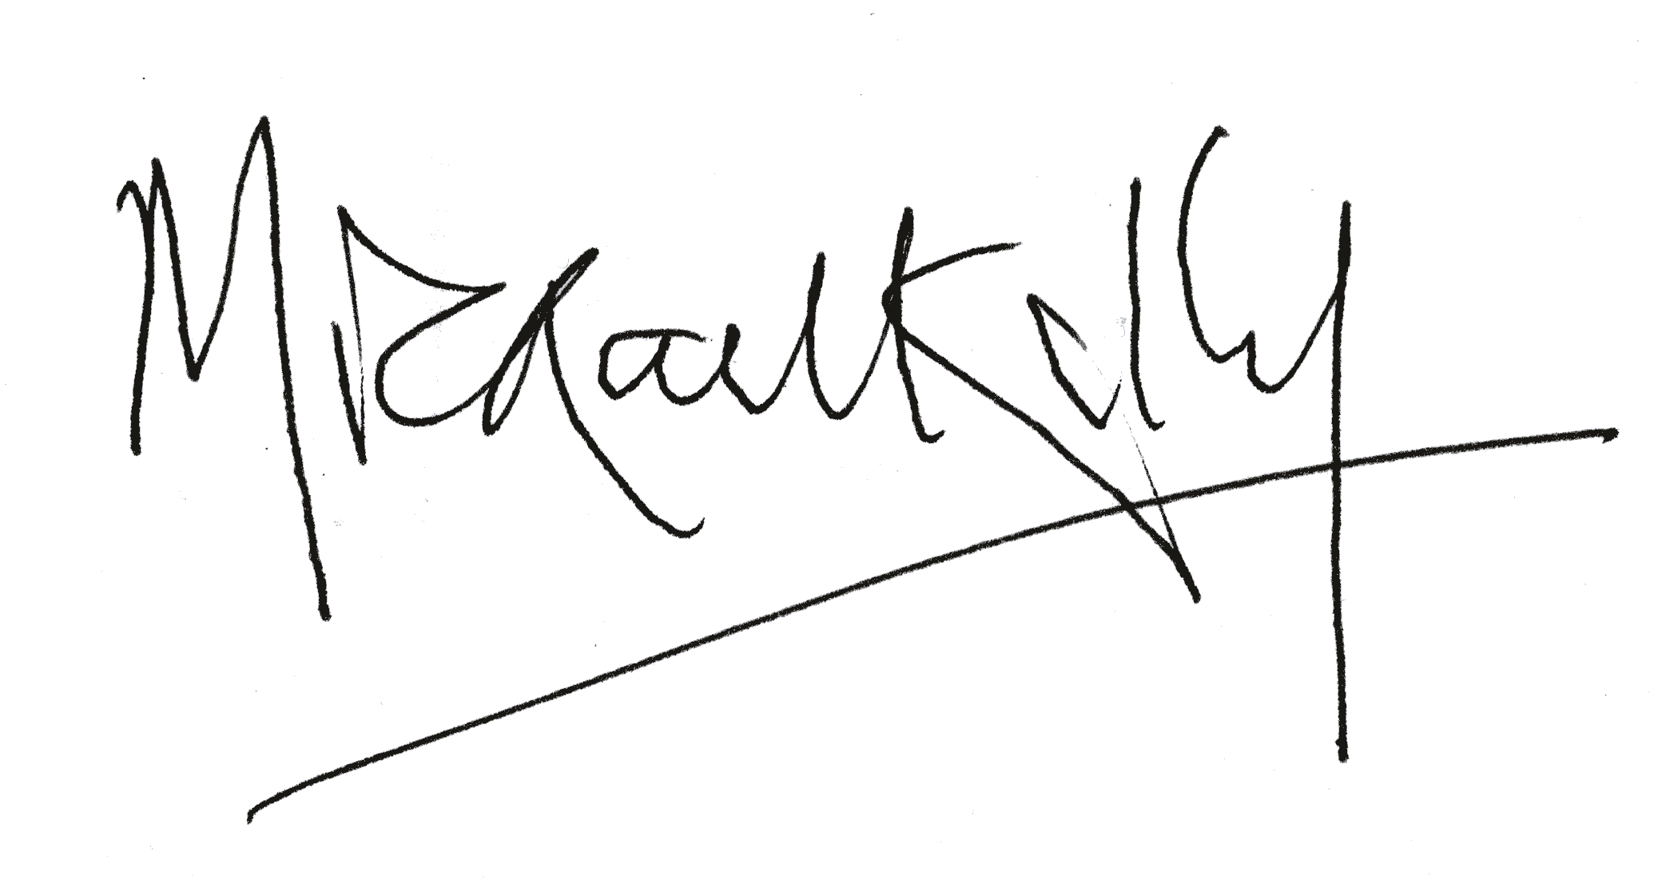

Prof. Mike Kelly
Director of LLAS Centre for Languages, Linguistics and Area Studies

For more information on other LLAS events check www.llas.ac.uk/events or contact us at llas@soton.ac.uk.

Programme
Language Futures:
Languages in Higher Education conference 2012

Provisional programme for day one: Thursday 5 July 2012

10.30-11.30 Registration, refreshments and exhibition FOYER

11.30-11.40 Welcome, introductions and housekeeping PENTLAND EAST
Michael Kelly, LLAS Centre for languages, linguistics and area studies
Peter Howarth, Association for University Language Centres (AULC)
Jim Coleman, University Council of Modern Languages (UCML)

11.40–12.10 Plenary 1: Shaping the Future of Languages in Higher Education
Professor Jim Coleman, The Open University
Chair: John Canning, LLAS Centre for languages, linguistics and area studies

12.15-13.15 Paper session 1

A – PENTLAND EAST | B - SALISBURY | C - HOLYROOD | D - PRESTONFIELD | E - DUDDINGTON
Chair: Jim Coleman | Chair: Vicky Wright | Chair: Peter Howarth | Chair: Angela Gallagher-Brett | Chair: ??????
Jane Vinther,  University of Southern Denmark  Language education at the centre of liberal education | Gary Quinn,  Heriot-Watt University  British Sign Language Interpreters don’t grow on trees! | Kate Borthwick & Alison Dickens, LLAS, University of Southampton  Coming in from the cold: recognition and reward for part-time language tutors through participation in the FAVOR project | Liz Andersen & Nick Johnston, Routes into Languages  Ambassadors:  From the Extracurricular to the Curricular | Giacomo Pierini  Sponsored by European School-books, Alma Edizioni  Chiaro!: il nuovo corso di Alma Edizioni: apprendere l'italiano attraverso una progressione lenta e graduale
Tricia Coverdale-Jones,  University of Portsmouth  Internationalisation of Higher Education in Japan and the UK - similarities and contrasts | Rita McDade, Heriot-Watt University  ‘Learning & Teaching, the Interconnectness of Communication and Language: An exploration of teaching methodologies used in BSL class, early learning experiences of BSL users and the influence on BSL learners today’. | Uwe Baumann & Elodie Vialleton,  The Open University  Academic mobility within a department:  what happens when French and German specialists work on an Italian distance course | Sarah Schechter,  & Mary Brittain,  Routes into Languages  Routes into Languages : Towards Sustainability | Nuria Lopez, Newcastle University  A case study: writing a Spanish dictionary as a collaborative task among beginner students.

13.15–14.15 Lunch RESTAURANT

14.15-15.00 PENTLAND EAST
Plenary 2: Doing residence abroad in a globalising world: Real, virtual and imagined communities
Professor Rosamond Mitchell, University of Southampton
Chair Jim Coleman, The Open University

15.00-16.00 Paper session 2

A - PENTLAND EAST | B - HOLYROOD | C - PRESTONFIELD | D - DUDDINGTON | E - SALISBURY
Chair: Jim Coleman | Chair: John Canning | Chair: Angela Gallagher-Brett | Chair: Laurence Georgin | Chair: Erika Corradini
Alison Dickens & Jaine Beswick, University of Southampton  A ‘REALIE’ useful experience: extending the employabliity benefits of work and study abroad for students of modern languages | Julia Kelly,  University of Southampton  Working towards theory: the accelerated ab initio language learning experience in Spanish and Portuguese at the University of Southampton | Fiona Graham, European Commission  Languages in action: translation in the European Commission | Edward Hoyle, Sponsored by Tell Me More  How Speech Recognition Technology can be used to practise and improve oral expression | Enza Siciliano Verruccio,  Alison Fenner & Alison Nader, University of Reading  teachOn!: New Words for New Worlds
Cathy Hampton & David Lees, University of Warwick  Telling Stories: Using Virtual Learning Spaces to Enhance the Year Abroad Experience | Ulrike Bavendiek, University of Liverpool  Motivational Processes and Practices in Accelerated Ab initio Language Learning | Anne-Marie Graham, Routes into Languages and  Acqueros  Public Service Interpreting and Translation in England: provision, policy and a community of practice | Billy Brick, Coventry University  What are the strengths and weaknesses of the language learning social networking site (SNS) www.busuu.com? | Teresa Mackinnon, University of Warwick  Using the virtual now to develop real language and communication skills for the future.

16.00-16.30 Tea and exhibition PENTLAND WEST

16.30–17.30 Paper session 3

A – PENTLAND EAST | B - DUDDINGTON | C - PRESTONFIELD | D - HOLYROOD | E - SALISBURY
Chair: Kate Borthwick | Chair: Liz Hudswell | Chair: Alison Dickens | Chair: John Canning | Chair: Peter Howarth
Dr Ruth Whittle, University of Birmingham  Year Abroad Matters: Change Management for students going to a European country and to a country with a non-Roman script | Philippe Liria, Sponsored by European School-books, DIFUSION  The theory of multiple intelligences in a language class | Dr Jean-Christophe Penet & Dr Sandra Salin, Newcastle University  Internationalising Language Teaching and Learning with the help of the Erasmus Community to Increase Employability - Results Carterf a Pilot Study. | Cristina Ros i Solé, University College London  Language Pedagogy for Global Citizenship | Beverly-Anne Carter, University of the West Indies  Challenging the stereotypes: making a case for non-specialist language learning in Caribbean HE
Patricia Romero de Mills & Rosamund Mitchell, University of Southampton  Language Assistantships and Student Exchange: a comparison of students’ linguistic development during different residence abroad programmes | John Morley, University of Manchester  A lexical spreadsheet for learners of Arabic | Ann Carlisle, Metropolitan Police Service  Putting languages to work – are degree programmes really delivering on employability? | Fabienne Boulogne, Sponsored by Editions Didier  Facilitating international mobility in the language class | Jonathan Lippman, University of Exeter  Flagging up success: Language electives named on degree titles – the Exeter model.

17.30-18.15 Plenary 3: Language Policy in Scotland PENTLAND EAST
Ms Sarah Breslin, Scotland’s National Centre for Languages (SCILT)
Chair: Michael Kelly, LLAS Centre for languages, linguistics and area studies

19.00–19.30 Drinks reception sponsored by KIRKLAND SUITE

19.30 Conference dinner SOUTH HALL

Provisional programme for day two: Friday 6 July 2012

07.00-08.30 Breakfast for overnight delegates

09.00-09.30 Registration for day 2 delegates and exhibition

09.30-10.30 Paper session 4

A - SALISBURY | B – PENTLAND EAST | C - HOLYROOD | D - PRESTONFIELD | E - DUDDINGTON
Chair: Vicky Wright | Chair: Alison Dickens | Chair: Peter Howarth | Chair: Nick Byrne | Chair: Erika Corradini
Chelo Martínez de Andrés, University of Plymouth  A Journey to the Heart of the Digilab: impact of 21st Century Technology Enhanced Language Learning in student and staff | Marion Sadoux, London Metropolitan University  Managing Transitions for Languages in Higher Education: "Leading from the Future as it emerges" | Marta Crosby, University of Southampton  Teaching learning strategies, does it work? A case study: stages 3 and 4 students at the University | Juliet Solheim & Heidi Solheim, University of Southampton  No guru, no method, no teacher: Learner approaches to extended reading in an undergraduate French language unit | Steve Eatock, Sponsored by Eurotalk  From Arabic to Zulu: how to introduce any of 100 world languages to your students using digital resources with a difference
Benoît Guilbaud, Manchester Metropolitan University  A review of staff engagement with digital technologies on an undergraduate language programme | Franck Michel, Newcastle University  Supporting the Development and Learning of Modern Languages students via the ePortfolio | Carmen Usategui & Susan Beigel, University of Chester  Facilitating autonomous learning at levels 4 & 5: some pedagogical approaches | Elisabeth Wielander, Aston University  Integrating Content and Language: An alternative approach to undergraduate language teaching and learning | Kate Borthwick and Antonio Martinez-Arboleda, Open LIVES Project  When research met teaching: publishing, collaborating and students as producers of open educational resources in the OpenLIVES project

10.30 –11.15 PENTLAND EAST
Plenary 4: Making the Case for Languages in Higher Education
Professor Colin Riordan, University of Essex
Chair: Michael Kelly

11.15 – 11.20 Prize draw - PENTLAND EAST

11.20-11.45 Morning coffee and exhibition PENTLAND WEST

11.45 – 12.45 Paper session 5

A - PENTLAND EAST | B - SALISBURY | C- HOLYROOD | D - DUDDINGTON | E - PRESTONFIELD
Chair: Kate Borthwick | Chair: Liz Hudswell | Chair: Laurence Georgin | Chair: Nick Bryne | Chair: John Canning
Anne Van Marsenille, IHECS  Informal language learning in Higher Education in Brussels: students’ perceptions | Kuei-Hsun Teng Flora, St Johns University  An Action Research of Applying Real-time Video Co-teaching with Cooperative Learning Strategy in Business English Curriculum | Josef Mueller, European Business School  The challenge of assessing reflective writing | Philippe Liria, Sponsored by European School-books, DIFUSION  Nouveau Rond-Point and Version Originale, two textbooks for a different teaching approach in French: approche actionnelle (task-based language teaching) | María Fernandez-Toro & Elena Polisca, The Open University & University of Manchester  Evaluating assignment e-feedback in Higher Education
Catherine Chabert & Helga Eckart, Cardiff University  Language provision for non-specialists in HE: Are we getting it right? | Barbara Unterberger, WU Vienna University  English-taught degree programmes in business education: programme design, implementation strategies and factors of success | John Christopher Wade, University of Cagliari  Metaphor and language of Education | Jasmina Nikolic and Jelena Gledic, University of Belgrade  Employers’ Take on Language Skills: A Case Study

12.45-14.00 Lunch and exhibition RESTAURANT

13.30-14.00 Humair Naqvi, “INSERT Title of Talk” - sponsored by Rosetta Stone PENTLAND EAST

14.00–14.45 Plenary 5: The language boost to Small and Medium (size) Enterprises exports PENTLAND EAST
Professor James Foreman-Peck, Cardiff University
Chair: Peter Howarth, University of Leeds

14.45–15.45 Paper session 6

A- PENTLAND EAST | B - HOLYROOD | C - PRESTONFIELD | D - DUDDINGTON | E - SALISBURY
Chair: Peter Howarth | Chair: Kate Borthwick | Chair: Liz Hudswell |  | Chair: Erika Corradini
Claudia Gremler, Aston University  The Benefits of Video Production Tasks as Language Learning Activities | Maria de Lurdes Correia Martins, polytechnic Institute of Viseu  Web 2.0 enhanced English language learning under Bologna | Angela Uribe-de-Kellett & Sandra Salin, Newcastle University  The Impact of Real Translation and Group Tasks on Language Students’ Learning Experience | Ali Dickens, John Canning & Laurence Georgin, LLAS Centre for languages, linguistics and area studies  Sharing Practice in Enhancing and Assuring Quality (Interactive Workshop) | Tim Lewis, The Open University  The INTENT Project: Integrating Telecollaborative Networks into Foreign Language Higher Education
Mariví Rodríguez Quiñones, King’s College London  Welcome the Error!! Drama techniques in Language Learning | Lik Suen & Liang Wang, SOAS  European Benchmarking Chinese Language: opportunities and challenges | Riita Liisa Valijarvi, University College London  Translating Google Translate to the Language Classroom: Pitfalls and Possibilities |  | Thomas Jochum-Critchley, University of Leeds  Back to the Future: Autonomous Language Learning Reloaded

15.45–16.15 Tea break PENTLAND WEST

16.15–16.45 Final plenary session PENTLAND EAST
Come and share:
1. One thing that has inspired you over the past two days
2. One thing you want to tell your colleagues who are not here
3. One thing you will do next year which you have never done before

Throughout the conference photographs will be taken which may be used by the conference organisers and sponsors on their websites or printed materials. If you do not wish to appear in any picture please let the people at the registration desk know.

Other LLAS events

"Multilingual Theory and Practice in Applied Linguistics" - BAAL 2012

Date: 6 September, 2012 - 8 September, 2012
Location: Physics Lecture Theatre A, Blg 46, Highfield Campus, University of Southampton
Event type: Conference

Making Video for Language Learning and Teaching

Date: 17 November, 2012
Location: Centre for English Language Teaching, Vanbrugh College, University of York
Event type: Workshop

2013

e-Learning symposium 2013

Date: 24 January, 2013 - 25 January, 2013
Location: Avenue Campus, University of Southampton
Event type: Conference

Get 50% OFF
your next LLAS workshop*
when you book it at the E-learning Symposium 2012!

Book now at the LLAS stand in room 1177

